1.) Bridged Networking is better option , gives support for everything.

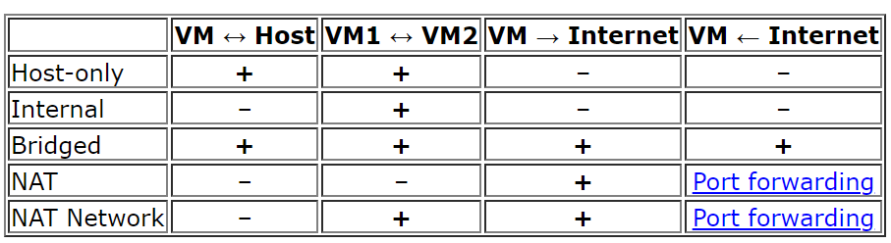

2.) LSI LOGIC only is recommended [ read stackoverflow answer below ]

SAS physical hardware has better performance than regular (parallel) SCSI hardware. Which does not matter for virtualization. Meantime the parallel SCSI driver is simpler. It's code base is older (more mature). So LSI Logic adapter has better (marginally but still) support in different guest OSes. Thus the recommendation.

3.) always choose SCSI over SATA

For SATA, you need to be careful about using a consumer drive if you are building a RAID array.

Some power saving features and in the case of Western Digital, some of their SATA drives have a "deep recovery" process when an error is detected. These can cause a SATA RAID member to be dropped or marked as failed if it is unresponsive beyond the timeout period.

When a SATA RAID5 volume with huge drives drops a member, it is not uncommon for the rebuild to take several hours. During this time, performance will be abysmal.

**Western Digital - difference between Desktop edition and RAID (Enterprise) edition hard drives?** <http://wdc.custhelp.com/cgi-bin/wdc.cfg/php/enduser/std_adp.php?p_faqid=1397>

<http://en.wikipedia.org/wiki/Time-Limited_Error_Recovery>